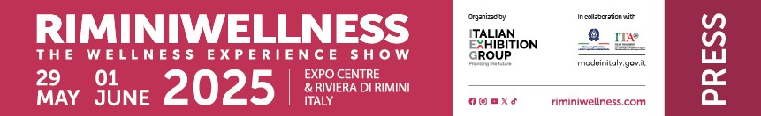

press release
(English translation)

RIMINIWELLNESS IS ALREADY WARMING ITS MUSCLES FOR THE 2025 EDITION,
THE GLOBAL WELLNESS PLATFORM, FROM 29TH MAY TO 1ST JUNE

- Italian Exhibition Group announces the dates for the 19th edition of its leading fitness, sport, wellness and healthy eating event
- After the last record-breaking edition, the 2025 appointment will be an increasingly international platform for trends and tendencies, innovation and business, networking and sector training
- Rimini Expo Centre and the Riviera as the chosen territory for thousands of enthusiasts, sportspersons and professionals from all over the world

www.riminiwellness.com

Rimini, 30th September 2024 – RiminiWellness, the international statement event for the promotion of healthy lifestyles and wellness in movement, will be back from 29th May to 1st June at Rimini Expo Centre and along the Riviera. These are dates set for the 19th edition of the event organised by IEG - Italian Exhibition Group, a platform for innovation, business and training for the community of fitness, wellness and healthy eating enthusiasts, sportspersons and professionals.

After the record edition of 2024, which saw the event come to a close with over 100,000 visits, double the number of foreign attendees and professional delegations from 25 countries, RiminiWellness is looking ahead to 2025 with the intention of strengthening its international and professional dimension even further, thanks to the development of projects and contents aimed at spreading the culture of wellness, health and longevity.

A successful format that has led the IEG event to be recognised as a platform that defines the future trajectories of the wellness industry. An offer that not only involves the consumer public, who, at RiminiWellness, will have the chance to discover training trends with the most innovative and trendy sports disciplines and competitions for staying in shape, but also gathers together the entire community of professionals thanks to the presence of globally renowned companies and brands operating in the production and distribution of fitness equipment, technological innovation in the sector, sportswear, food and nutrition.

The next edition of RiminiWellness will once again act as an aggregator of the main institutions, trade associations, public and private organisations, research centres and university institutes to establish a European hub for training, updating and specialised theoretical and practical information for physical and mental wellbeing operators and professionals.

A four-day sports and health event that will extend from the over 190,000 square metres of Rimini Expo Centre’s indoor and outdoor areas to the Riviera, thanks to the development of off-show content organised in cooperation with Rimini City Council. More than 240 events were promoted in the last edition, taking an area with a considerable vocation for sports and a high accommodation capacity to a destination for thousands of sportspersons and enthusiasts from all over the world. Rimini, which last August became part of the “Italian Healthy Cities Network”, an initiative promoted by the World Health Organisation (WHO), is a city which, thanks to the RiminiWellness event, is increasingly becoming the wellness destination for Italian and foreign fitness and wellness enthusiasts.

ABOUT RIMINIWELLNESS 2025
Dates: 29 May - 1 June 2025; event: international trade show; organiser: Italian Exhibition Group S.p.A.; frequency: annual; edition: 19th; entry: public and trade; info: www.riminiwellness.com

PRESS CONTACT ITALIAN EXHIBITION GROUP
head of corporate communication & media relation: Elisabetta Vitali
press office manager: Marco Forcellini, Pier Francesco Bellini | press office coordinator: Luca Paganin | international press office coordinator: Silvia Giorgi | press office specialist: Mirko Malgieri; Nicoletta Evangelisti | media@iegexpo.it

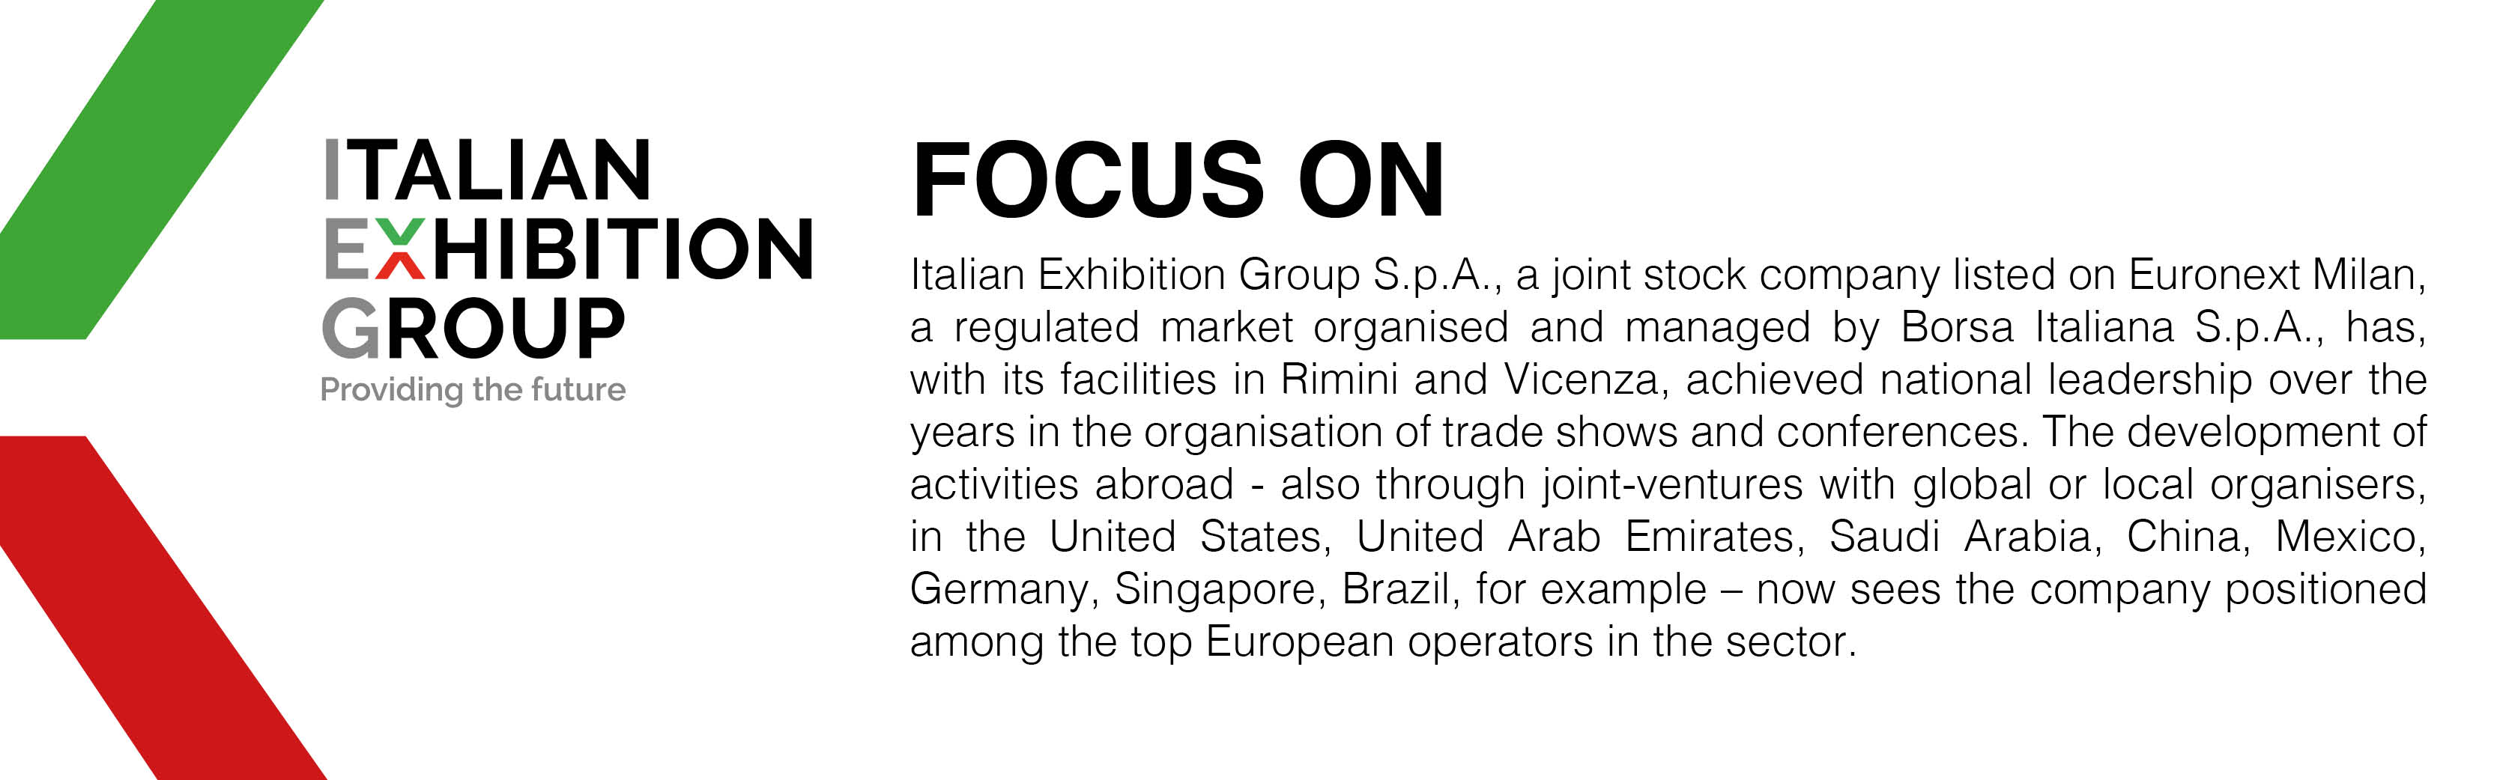

This press release contains forecast elements and estimates that reflect the management’s current opinions (“forward-looking statements”), particularly regarding future management performance, realization of investments, cash flow trends and the evolution of the financial structure. For their very nature, forward-looking statements have a component of risk and uncertainty, as they depend on the occurrence of future events. The effective results may differ (even significantly) from those announced, due to numerous factors, including, only by way of example: food service market and tourist flow trends in Italy, gold and jewellery market trends, green economy market trends; the evolution of raw material prices; general macroeconomic conditions; geopolitical factors and evolutions in the legislative framework. Moreover, the information contained in this release does not claim to be complete, and has not been verified by independent third parties. Forecasts, estimates and objectives contained herein are based on the information available to the Company as at the date of this release.

